**Academic Services Group**

Planning Poker somewhat helped out with story point estimation. However, as we progress, it is becoming clear how challenging it is to estimate the point value for each user story before beginning work on the task. We had some debate over the point value for the following user story: “As a developer, I want to create a consistent design and color scheme laid out in a style document so it can be referenced when creating and adding to pages.” We had some difficulty determining how detailed and complex this task would be at this point in the project. Discussion led us to deciding that a more intensive UI design stage would come later in the project. Other than this, we each generally had extremely similar estimates that varied only slightly, which lead to a simple compromises.

For this sprint, we mainly met in person for our daily scrums. We arranged our meetings on GroupMe. Typically, we meet around 5:00 P.M. at night (whenever everyone was available and off work). This occasionally fluctuated to be earlier in the afternoon around 3:00 P.M. (after class) or later in the evening around 9:00 P.M. When we were not able to meet in person, we used Google Hangouts to video call. These calls happened around 5:00 P.M. or 5:30 P.M. (depending on how long it took to get each member on the call). Therefore, we were able to have brief meetings even on particularly busy days when we could not more effectively coordinate our schedules. The time for our daily scrums ranged from 10 to 30 minutes; however, some of them were considerably longer whenever many things needed to be discussed/addressed.

The estimated velocity for our sprint was 52 story points. The actual velocity for our sprint was 62 story points. We completed everything we originally set out to complete during this sprint. Kaleigh Key had to grab another story because creating the “What’s Around Me” button with the set geographic polygon did not take as long as anticipated. The new story, worth 8 story points, was created to add onto the location aspect of the application (GPS integration). Brad Ewing grabbed another story to allow for improving the search by county method. He made this decision because he determined that the story was required for this sprint to thoroughly accomplish his other stories. Also, we added a story for creating at least 15 tests during the span of this sprint. This story was completed by four of the team members (Brad Ewing, Shelby Pace, Christopher Hebert, and Kaleigh Key). Nathan Cooley, Brad Ewing, Kaleigh Key, Christopher Hebert, Michael Towns, and Shelby Pace all completed the stories they initially decided to finish by the end of the sprint. The story concerning the GPS integration, which was added to the sprint by Kaleigh Key, was not completed during this sprint, but it was worked on for a considerable time span. Our project is currently potentially shippable. The user now has the ability to search by county and by common or scientific name (meaning they can also switch between search methods). Also, the user can load more results if they wish, and the populated list of species names are selectable. Selecting the species name now takes the user to a page with more information about the species. We were able to get the application to a place where it has real life value to a user.

**Story points:**

**Nathan Cooley** Set out to accomplish: 8 Actually accomplished: 8

**Brad Ewing** Set out to accomplish: 18 Actually accomplished: 24.25

**Chris Hebert** Set out to accomplish: 8 Actually accomplished: 9.25

**Kaleigh Key** Set out to accomplish: 3 Actually accomplished: 4.25

**Shelby Pace** Set out to accomplish: 9 Actually accomplished: 10.25

**Michael Towns** Set out to accomplish: 6 Actually accomplished: 6

**Commits:**

**Nathan Cooley** Total meaningful commits: 1

**Brad Ewing** Total meaningful commits: 11

**Chris Hebert** Total meaningful commits: 4

**Kaleigh Key** Total meaningful commits: 10

**Shelby Pace** Total meaningful commits: 10

**Michael Towns** Total meaningful commits: 9

We used behavior testing for this sprint. The tests we created were manual (to be completed by a developer or a user). We made sure every test passed before the sprint was officially done. However, some code was committed a few minutes after midnight (technically the next day). Brad Ewing, Shelby Pace, Christopher Hebert, and Kaleigh Key all created/wrote tests. Every team member helped with verifying that the application passed each test (running the tests manually).

For our next sprint, we may slightly increase the amount of planned story points; however, we may keep the story points at about the same amount. Some team members felt as though they had to add additional stories or work on additional tasks, but other team members had more than enough work to do for the sprint. These other members are concerned to overload on the upcoming sprint. In regards to differences in the upcoming sprint, we are going to attempt to coordinate or code more consistently throughout the sprint. We also hope to accomplish more error handling within this sprint. As always, we could improve upon our communication and how/when we push and pull code.

**Burndown Chart and Tables:**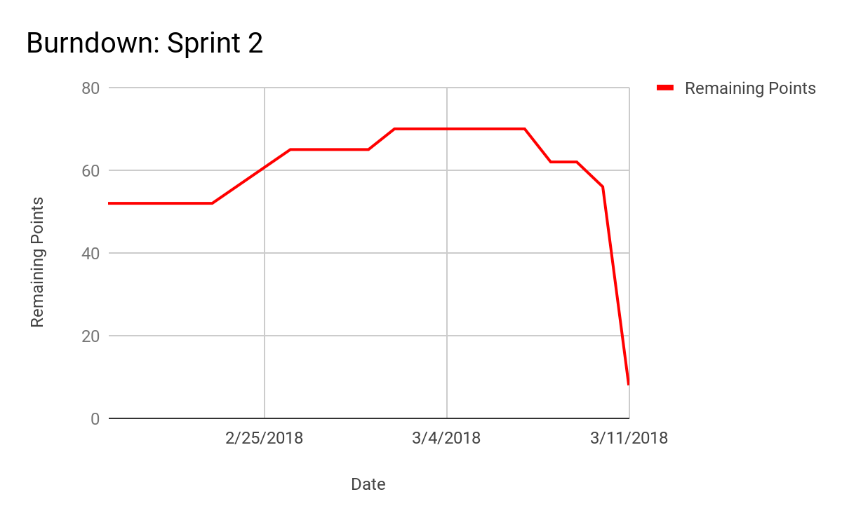

|  |  |
| --- | --- |
| **Date** | **Remaining Points** |
| 2/19/18 | 52 |
| 2/20/18 | 52 |
| 2/21/18 | 52 |
| 2/22/18 | 52 |
| 2/23/18 | 52 |
| 2/26/18 | 65 |
| 2/27/18 | 65 |
| 2/28/18 | 65 |
| 3/1/18 | 65 |
| 3/2/18 | 70 |
| 3/5/18 | 70 |
| 3/6/18 | 70 |
| 3/7/18 | 70 |
| 3/8/18 | 62 |
| 3/9/18 | 62 |
| 3/10/18 | 56 |
| 3/11/18 | 8 |
| **Velocity** | 62 |

|  |  |
| --- | --- |
| **Date** | **Stories Moved to Done** |
| 3/8/18 | (8) As a user, I want to be able to choose what I am searching by so that I can switch what I am searching for. [8] |
| 3/10/18 | (3) As a developer, I want to search by scientific name so information is returned about the species. [2] |
| (3) As a developer, I want to search by common name so information is returned about the species. [8] |
| 03/11/18 | (5) As a developer, I want to create 15 tests so that I can have a routine way of checking and improving the application's functionality. [5] |
| (3) As a developer, I want to create a "What's Around Me?" button so that I can view the species in a set geographic area. [3] |
| (3) As a user, I want the results to be selectable so that I can move to the species page for that entry. [2] |
| (5) As a developer, I want to create a consistent design and color scheme laid out in a style document so it can be referenced when creating and adding to pages. |
| (3) As a developer I want to make all of the pages conform to the style document. |
| (5) As a developer, I want to improve search by county so that... [8] |
| (5) As a user, I want to load more results by scrolling to the bottom of the screen and selecting a "Load more" button so that I can view more results. [8] |
| (13) As a developer, I want a layout of all the pages of our application so that we have a starting point when we begin designing these pages. [8] |
| (1) As a user, I want to move to a species page when I select a species from the list so that I can view more information about it. [0] |
| (5) As a developer, I want the species page to be populated with information about the species so that the user can learn more about that species. [5] |